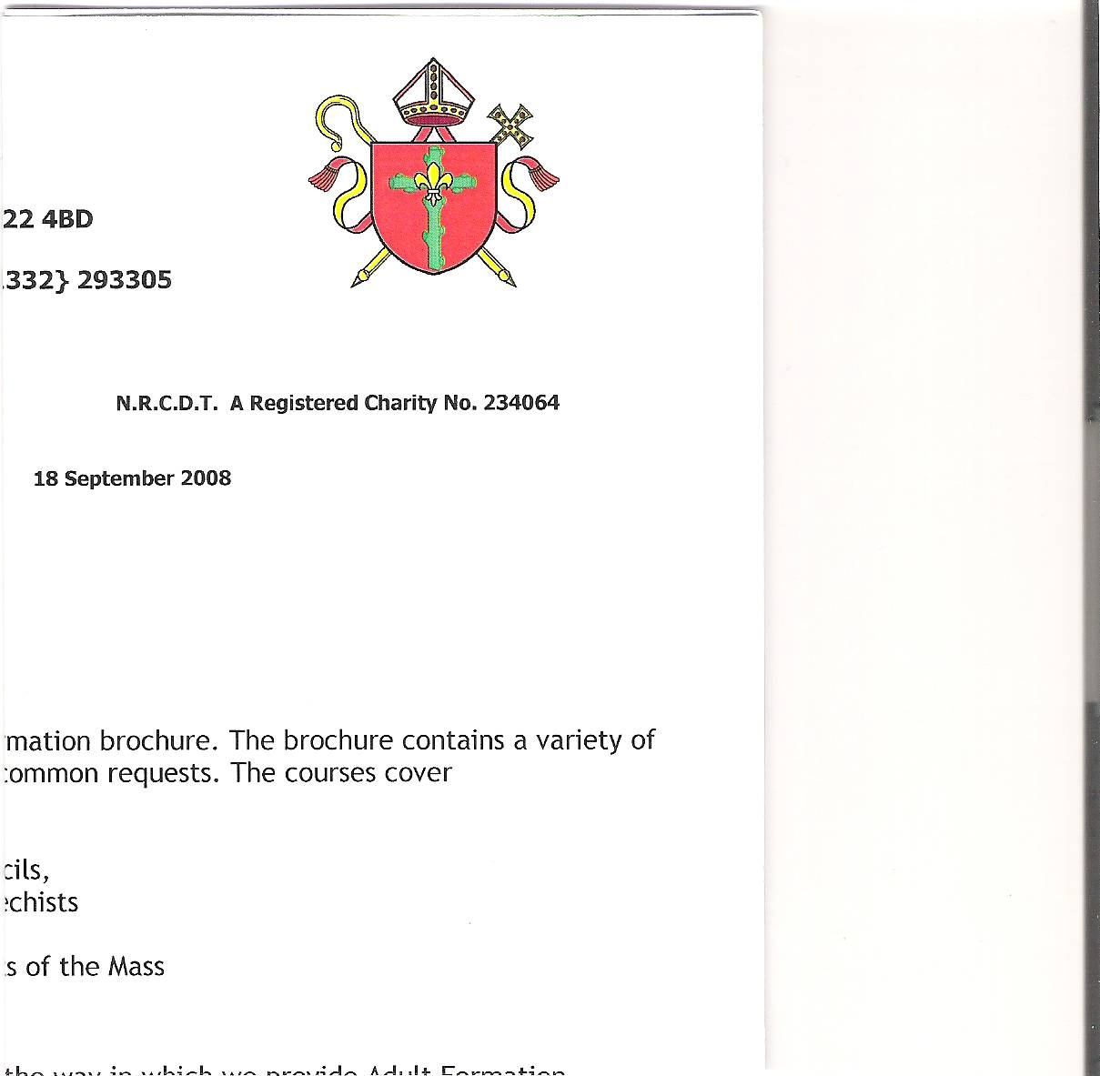

**Holy Cross Parish**

**Hucknall**

**HOLY CROSS PARISH PASTORAL COUNCIL MEETING**

**6th April 2025**

**ATTENDEES: APOLOGIES**

Father Richard -President Lauren Whitehouse

Simon Clunie - Chair Jackie Ortega

Vivien Flynn – Minutes Alex Ademiju

Bill Flynn Charles Nyarkoh

Lucas Ortega

Chris Wisniewski

Sue Hanson

Vaughan Gallagher

Steve Pepper - Facilities Manager

**WELCOME AND APOLOGIES**

Following the opening prayer by Simon, he welcomed everyone to the meeting with a special welcome to Steve Pepper, the Facilities Manager for Holy Cross Church. Apologies received were noted.

**REVIEW OF MINUTES OF LAST MEETING 11th December 2024**

The Minutes were approved as a correct interpretation of the meeting held on 11th December.

**MATTERS ARISING**

**Presbytery Agents**

Following lengthy discussions during several meetings it was agreed by the Parish Council that we should employ a new agent following the agreement of the Diocesan office and Rachael Oxspring. Father Richard has approved this change and the office in Bulwell has been informed and will ask Rachael to cancel the contract with Spencer Birch with immediate effect. Several agents have been asked to submit their Terms and Conditions, it has been agreed that Bairstow eves in Hucknall offer the best terms. The Diocesan office will appoint new agents.

**Finance Update**

Lucas informed the council that we have approximately £59,000 in the current and Set Off account combined. Once the heating is paid for it will leave a balance of approximately £11,000. We are currently spending more than we are bringing in.

**Action point:** Welcomers to distribute Gift Aid envelopes a week before each monthly second collection for heating.

**Heating**

Vaughan provided an update on progress and confirmed a finish date of 16th April. It was originally due to finish on Friday 11th but one of the components arrived damaged causing this delay. Emma will inspect the premises on completion. Several people will be trained to operate the new system at a time and date to be confirmed:

Steve Pepper, Vivien Flynn, Mary Umney Bodwell Mendy and Ciprian Blaj.

**Action point:** Olimpia to ask the cleaners to clean on Thursday 17th in time for the Good Friday Service on 18th April.

**Health and Safety**

New Fire Exit: Steve reported a risk assessment is required by the Diocese regarding the fire risk at Holy Cross during Mass at Easter. The R.A. will be tailored to cover this.

**Action point:** Paul Glover has agreed to oversee the logistics during the Easter Triduum and Simon Clunie will assist. Steve to contact both to arrange how this will be achieved.

**Safeguarding**

Roselyn has completed the safeguarding audit.

**Action point:** No further action required.

**Fundraising**

An events group has been formed by Lucas & Jackie Ortega, Stephanie Graham MacLeod, Charles Nyarkoh and Bodwell Mendy. They have successfully organised events to raise money for the heating and have future plans for a VE Day Celebration and a Summer BBQ.

**Action point:** Proceed with plans for the above celebrations.

**Parish Merger**

The Diocese has confirmed that Holy Cross Hucknall is to merge with Our Lady’s Bulwell by April 2026. A Parish Merge Committee has been set up consisting of Pauline Lynch - Chair, Simon Clunie, Lucas Ortega, Deacon Martin and Bridget Doyle, so there will be two members from each church as representatives. There will be one Pastoral Parish Council and one Finance Committee with representatives from both churches. The Bishop wants to reduce the number of parishes due to the lack of priests and this will mean Father Richard only has to attend one PPC Meeting and one Finance committee meeting. There will be a parish consultation and a talk from the lecterns during May, explaining how this will work. Finance will remain separate.

**AOB**

There has been a modest turnout to the Lenten Reflections events although the event run by Fr. Joe Hanlon was well attended.

**Action point:** No action required.

We have received confirmation from the local council that the meeting room will be required again for the local elections.

**Action point:** Chris confirmed he will be available for setting up on 28th April at 1.15pm.

Vaughan has asked it to be Minuted that he is unhappy with the decision of the parish office to use Ackroids or Gouldings to undertake the Fire Exit work as he considers it would be unprofessional to undertake the work without a specification. He has asked Alan Joyce to tender building planning and H & S approval. He also said detailed scale drawings would be required for Fire Safety approval, which they would provide. Rachael Oxspring told Vaughan to go ahead.

Due to the financial situation Holy Cross is in, it is felt that we need to ensure we do not incur unnecessary costs and therefore Ackroids and Gouldings have been approached.

**Action point:** Father Richard to decide once all costs have been submitted.

**Date of next meeting**

The date of the next meeting is to be confirmed.

**Concluding Prayer**

Father said the concluding prayer and the meeting closed at 8.30pm.